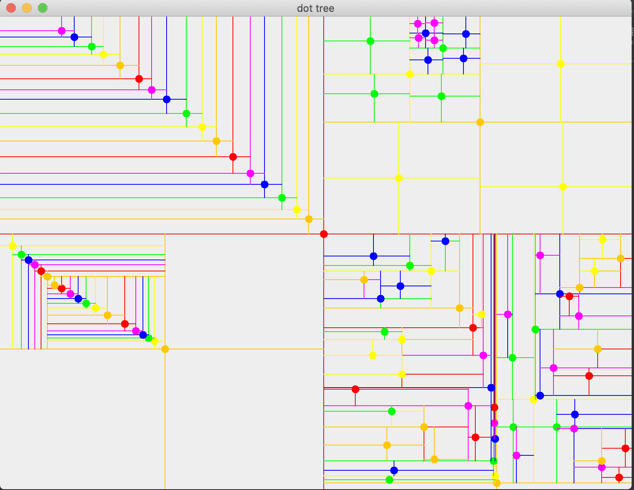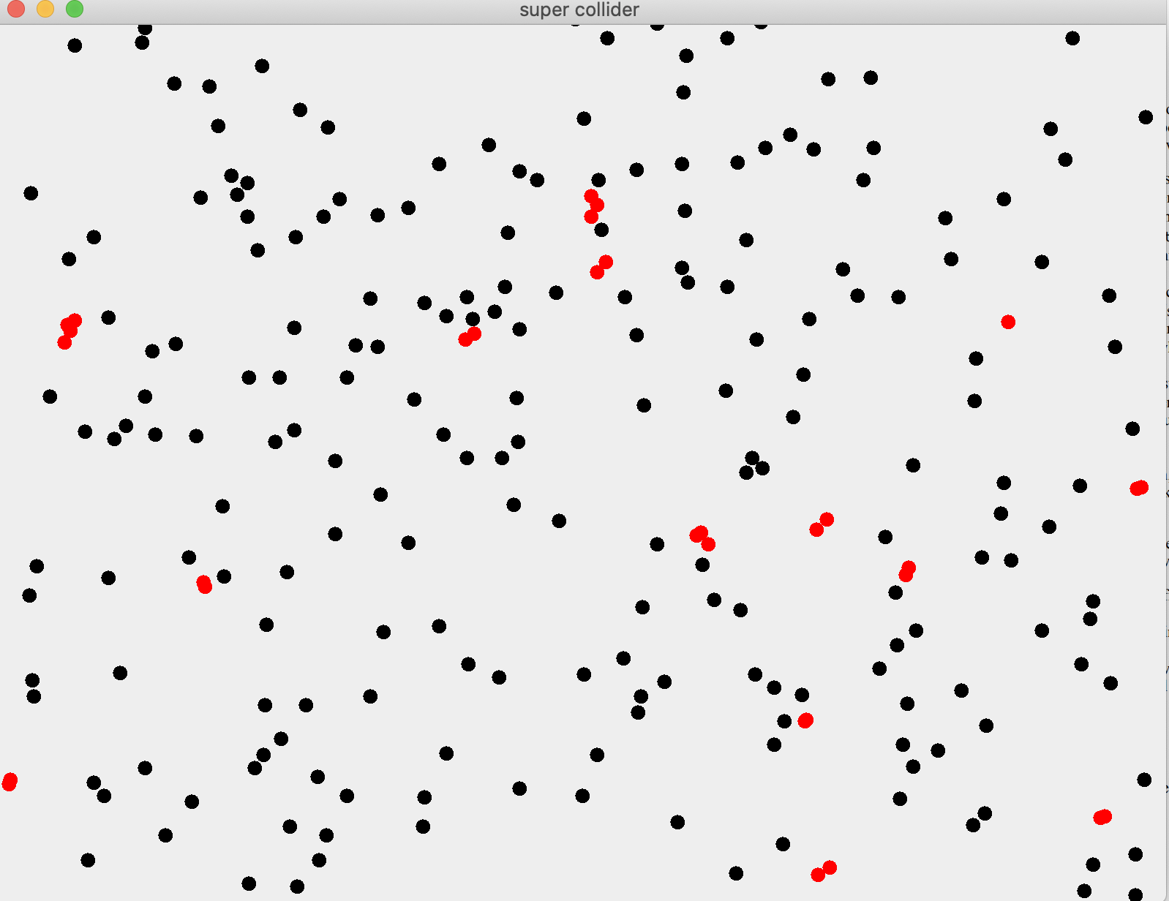

See screenshots of GUIs in action above:

Discussion:

Our test2 method in QuadtreeTest tested all of the QuadTree point methods we created.

The first part of our test creates our Quadtree, thoroughly testing our insert method as it does so. Next, we test our toString method by printing out our Quadtree. This also confirms that our QuadTree was properly constructed. Next, we print out all the points in the tree, checking both our allPoints method, and its helper method. Next, we print out all the points within the preset circle in the center of the tree, checking both our findInCircle method, and its helper method. We set the radius of our circle to only include two points, and created a tree of total size 12. The next part checks that there were only two points found in the circle, and that all 12 points were properly added to the tree. If these conditions are met, then the test prints out that you passed.

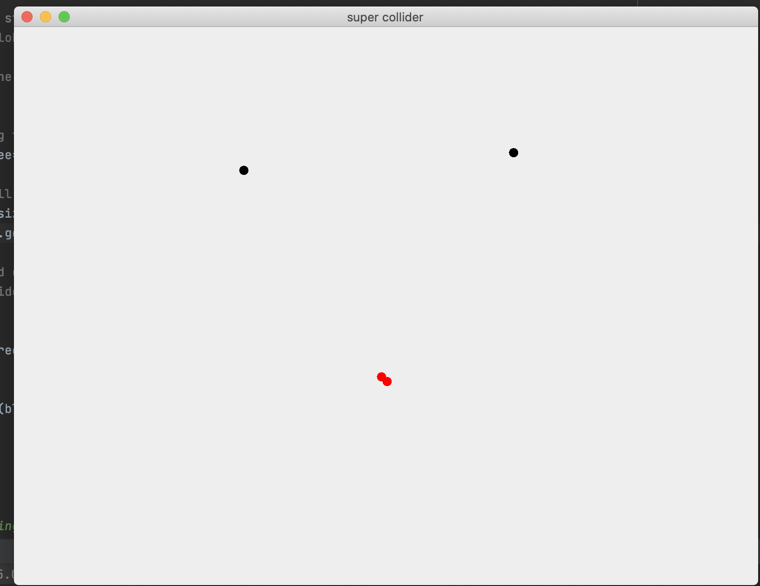

This is our CollisionGUI test. We see two blobs that are clearly alone and not colliding, and these are black. We also have two blobs that are colliding, and they are red. As seen in the top image, when there are many blobs, this behavior still occurs.